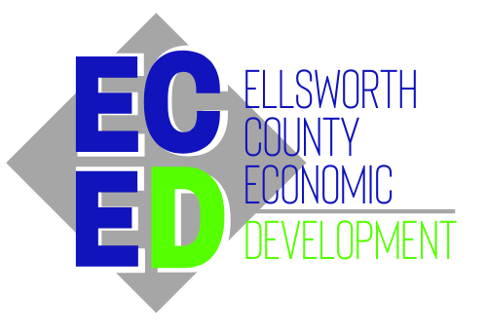

REVOLVING LOAN POLICY AND PROCEDURES
Use of funds: Gap funding for purchasing a building, purchasing equipment for a business, purchasing land for a business, working capital, construction or renovation on a business, special projects
Terms: Up to 60 months, subject to review and discretion of the Board of Directors
Qualifications: Business must be located in Ellsworth County and be a for-profit entity
Interest: 1% below New York Prime and not less than 3% fixed, and annually adjusted after any 60 month terms
Credit Score: ECED reserves the right to obtain credit scores and/or a copy of the credit report from a traditional lender
Application Fee: $100.00 – ECED is pleased to offer you a Silver Membership to our organization for one year in exchange for the application fee.
Late Fee: The lesser of $50 or 5% of the scheduled payment with a 15 day grace period. Clients who are over 15 days late shall receive reminder letters, with follow up and correspondence until payments are made. After 90 days or no payments or attempts to make payment arrangements, the loan shall be considered in default.
Maximum loan amount: At the discretion of the Board of Directors
Amortization/Simple Interest: Simple Interest based on 365 days
Default: Any clients over 90 days will be served with Limited Action proceedings.
Monthly Payments: Preferred payment method is via direct deposit to First Bank Kansas on the due date
Fees: ECED shall receive 25% of all collected interest payments for servicing the loans. The remaining interest shall remain in the account for additional loan funds. The borrower shall pay any third party fees.
Board Scoring Criteria: Scoring criteria could be based on financial soundness, owner/operator experience, business plan, projected growth and economic impact including job creation, business development partnerships, quality of life impact

