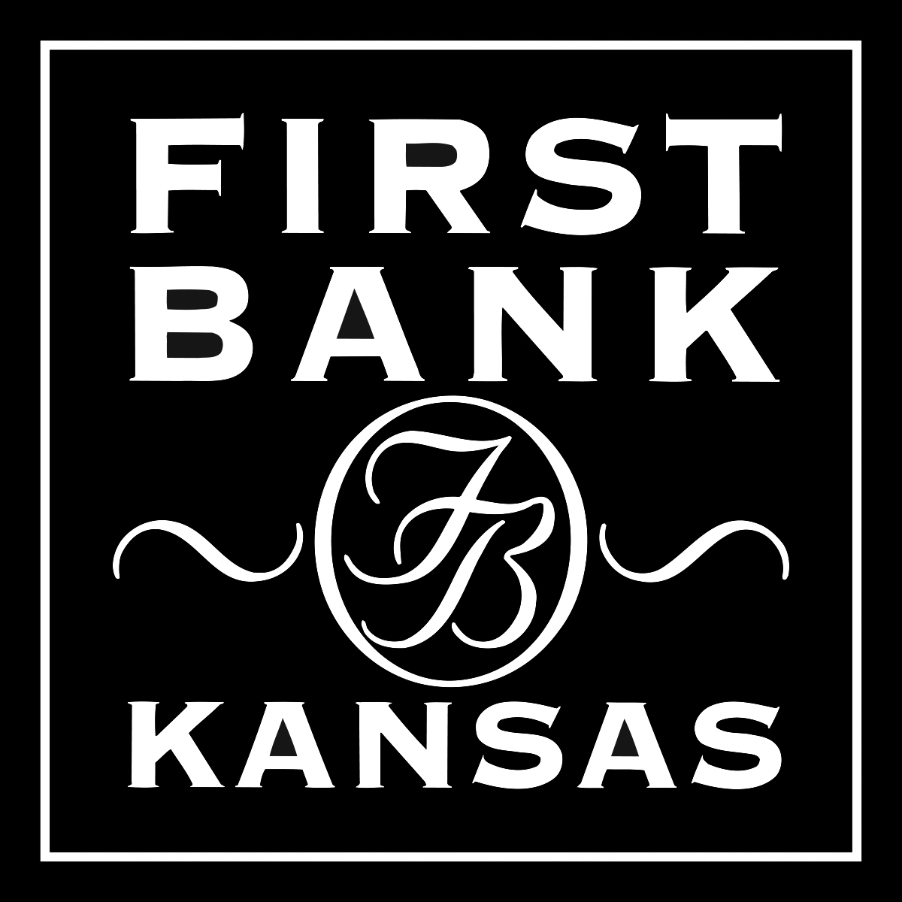

Ellsworth Branch Manager/Ag & Commercial Lender

First Bank Kansas has a culture that is team-oriented, customer and community focused and where loan decisions are made locally. We have a great opportunity for an individual to manage and grow our Ellsworth market. The ideal candidate will have a bachelor’s degree and 2-4 years of experience in commercial and/or agricultural lending with a strong focus on management and business development. This person must have the ability to communicate effectively at all levels of an organization and be active in the community while promoting the bank.

First Bank Kansas offers a competitive compensation package and comprehensive benefits for full-time positions.

To apply, please send resume with cover letter and salary requirements to Human Resources, First Bank Kansas, PO Box 1337, Salina, KS 67402-1337. Resumes can also be e-mailed to mdavidson@firstbankkansas.com. An online application can be found at www.firstbankkansas.com under the “About” tab. Equal Opportunity Employer.

